UCL Early Career Teacher (ECT) Full Induction Programme (FIP)
Early Career Framework (ECF)
The ECF sets out what all ECTs should learn about and how to do during the first two years of their careers and has been designed to make sure early career teachers focus on learning the things that make the most difference in the classroom and their professional practice.
The ECF is not an assessment tool and does not replace a school’s chosen appropriate body assessment process. Click here to find out more about the Teach West London Appropriate Body Service.

UCL Full Induction Programme (FIP)
Module overview
The programme is made up of 9 modules over 2 years (5 modules in Year 1 that introduce the 8 standards of the ECF, and 4 modules in Year 2 that deepen the ECT’s knowledge and practice)
Year 1 modules: (1) Enabling pupil learning, (2) Engaging pupils in learning, (3) Developing quality pedagogy, (4) Making productive use of assessment, (5) Fulfilling professional responsibilities.
Year 2 modules: (6) Inquiry into enabling pupil learning, (7) Inquiry into engaging pupil learning, (8) Inquiry into developing quality pedagogy and making productive use of assessment, (9) Fulfilling professional responsibilities.

Induction Tutor
In each school, there is an Induction Tutor (most likely but not necessarily the former NQT PCM), who oversees the successful implementation of the programme in each school.
The Induction Tutor is responsible for ensuring that suitable teachers are appointed to as mentors on the programme and that these mentors are well supported to fulfil their role.
This support may include:
- Ensuring that the Mentor is familiar with the content and purpose of the ECF
- Ensuring the Mentor and the ECT have the required time necessary to prepare for and attend their regular meetings
- Acting as a point of reference if the Mentor has questions or concerns relating to their mentoring role or the progress of their ECT
Guided self-study
Both the ECT and the Mentor complete regular guided self-study throughout the 2 years.
ECT self-study typically precedes the ECT mentor meeting, which is designed to review and develop the activities begun in self-study.
Mentor self-study targeting knowledge of content from the ECF and the mentoring approaches that underpin the programme.

Mentor meetings
Each ECT has a Mentor. The mentor is a suitably experienced teacher who is responsible for organising and leading the mentor meetings. ECT mentor meetings are 50 minutes in length, within an allotted programme time of 60 minutes. The remaining 10 minutes allow for some preparation by the mentor and for the ECT to put into practice the actions they set in each ECT mentor meeting.
The meetings are organised under standard headings:
Review activities relate to action points set by the ECT in the previous week’s meeting to ensure continuity.
Plan activities based on outcomes of the module audits to best address the learning needs of the ECT
Theory of Practice activities are the main body of each meeting and build on the ECT self-study. Mentors should make use of these activities as best matches the ECT’s individual learning needs—there is no expectation that all activities will be completed in full, each week. A range of activities is offered to support mentors to personalise each meeting.
Next Steps activities enable the ECT to commit to putting their learning from the week’s sessions into practice. 25 minutes is built into the programme time each week for the mentor to support the ECT to put their learning into practice. These actions are then picked up in the next week’s ‘review’ activity.
The meetings are structured by a Research and Practice Summary which targeting statements from the ECF. , and session elements that deepen learning in relation to targeted content. ECTs set actions arising from these meetings for putting their learning into practice in the following days.
The programme consists of annual conferences for the ECT and the Mentor, regular Mentor meetings, guided self-study for the ECT and the Mentor, facilitated training sessions for the ECT and Online Learning Communities for the ECT and the Mentor.
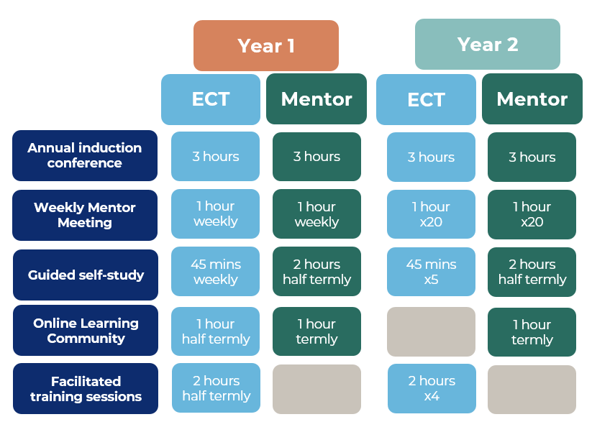

Facilitated training sessions and Online Learning Communities
Each ECT attends a 2-hour facilitated training session each half term with the exception of the summer term in Year 2. ECTs are in groups of approximately 20, clustered by phase and geographic location. The sessions target statements from the ECF, complementing and enhancing learning from ECT self-study and ECT mentor meetings. The sessions are delivered by Local Partners using materials provided by UCL and contextualised to meet the needs of the each group.
ECTs and Mentors take part regular Online Learning Communities. ECTs and Mentors are in groups clustered by phase and geographic location. The sessions target statements from the ECF, complementing and enhancing learning from ECT/Mentor self-study and ECT mentor meetings. The sessions are delivered by Local Partners using materials provided by UCL and contextualised to meet the needs of the each group.

UCLeXtend
Once an ECT or Mentor is successfully registered with Teach West London and the DfE, they will be given access to the UCL learning platform UCLeXtend. This is where they can access materials, videos and show their engagement with the programme through surveys and audits. Induction tutors will also be provided with a login to UCLeXtend so they can have oversight of the Module Materials.

